Project 2

1.What countries or regions rank the highest in overall happiness and each of the six factors contributing to happiness?

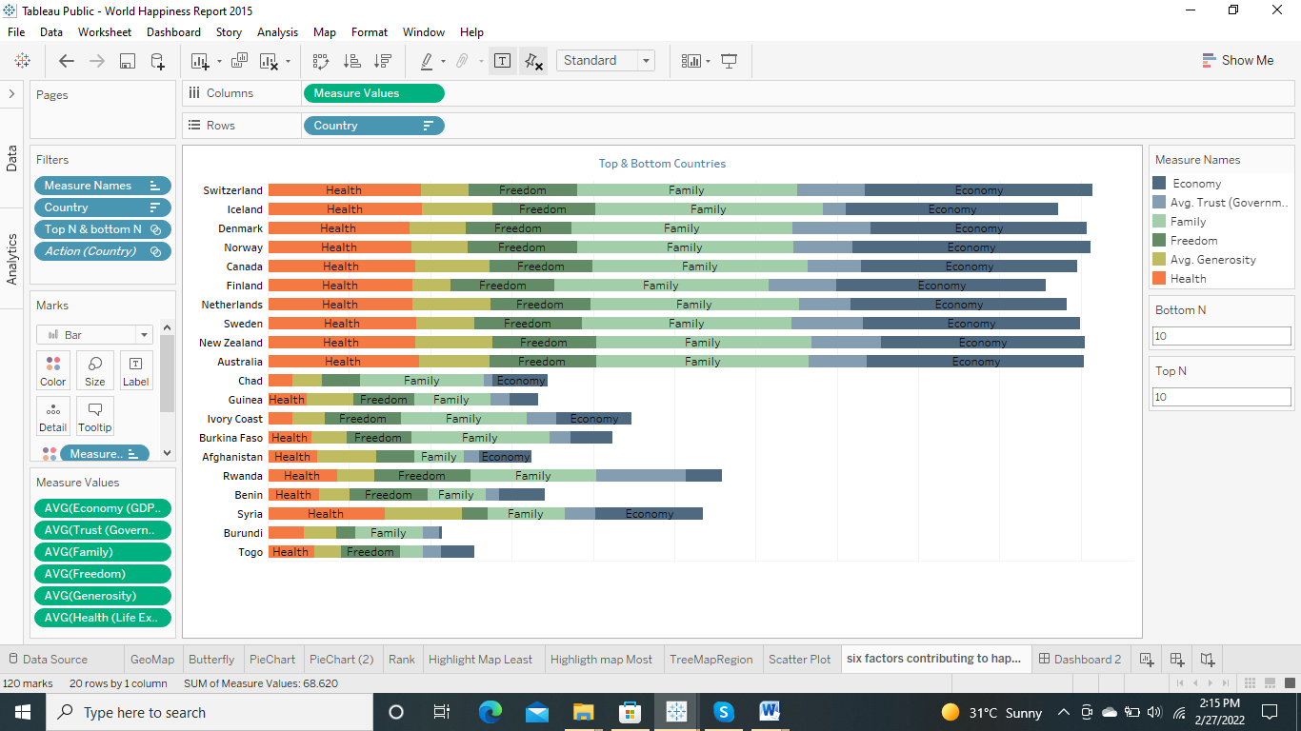

2.How did country ranks or scores change between the 2015 and 2016 as well as the 2016 and 2017 reports?

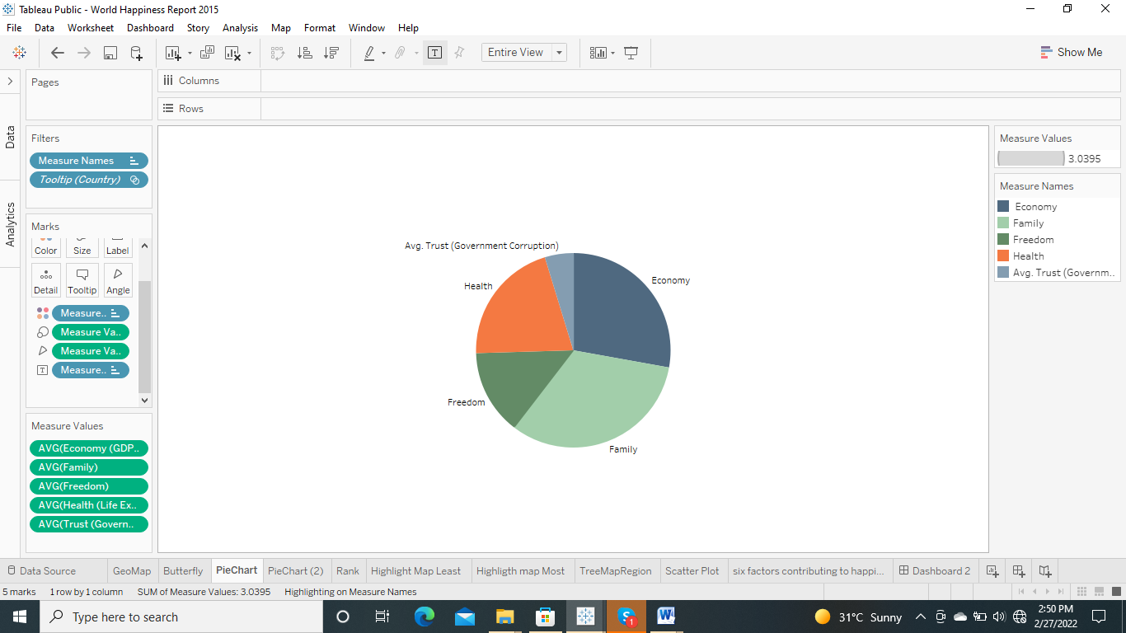

3.Did any country experience a significant increase or decrease in happiness?

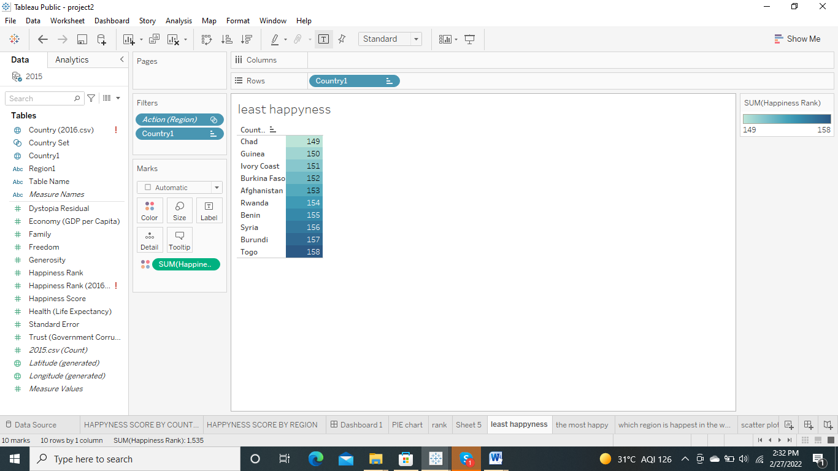

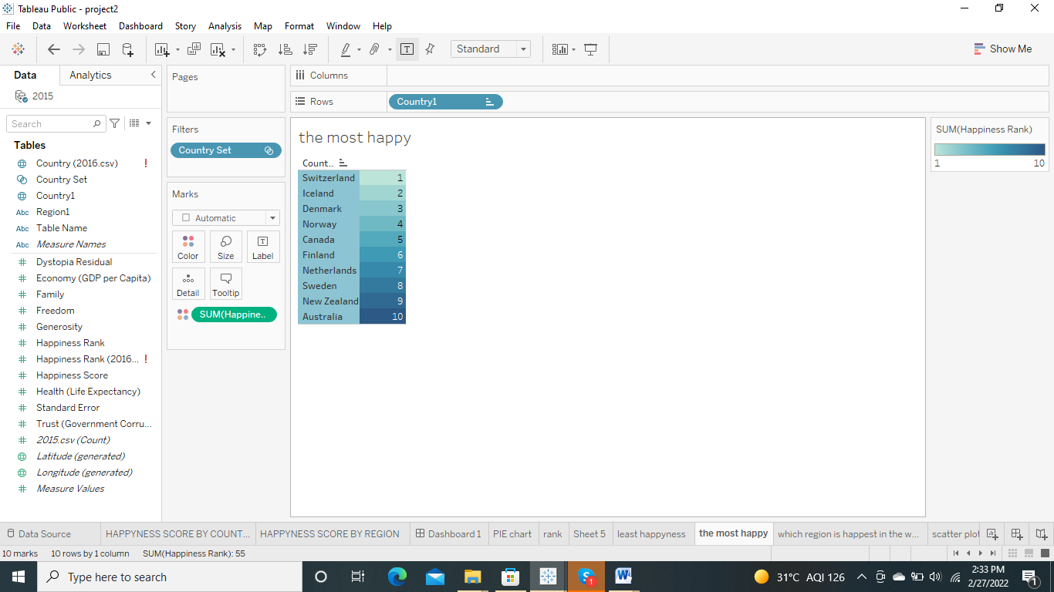

4.Can we conclude that high Economy (GDP per Capita) country trends to be happier?

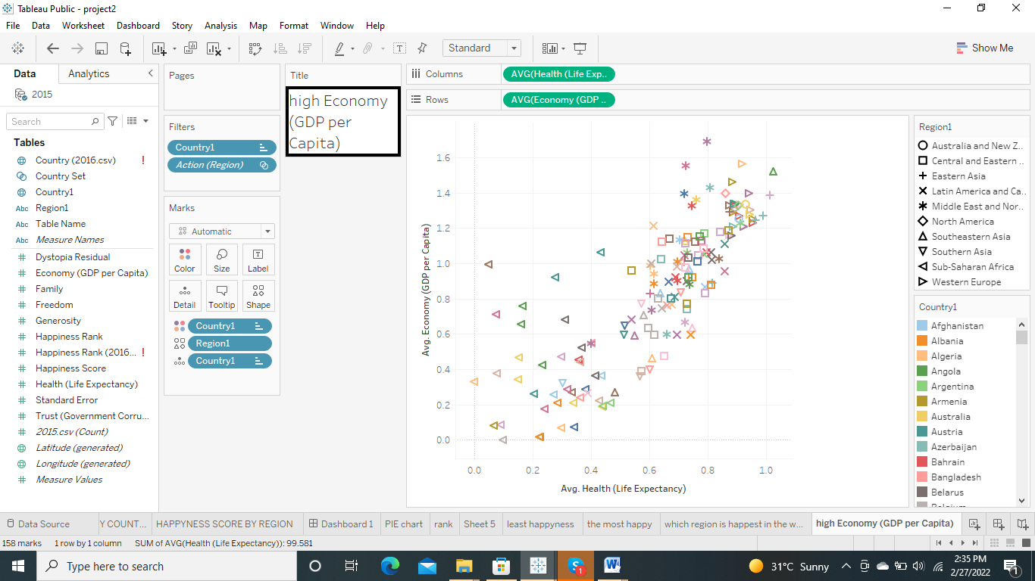

5.What are the factors influence Happiness Score positively?

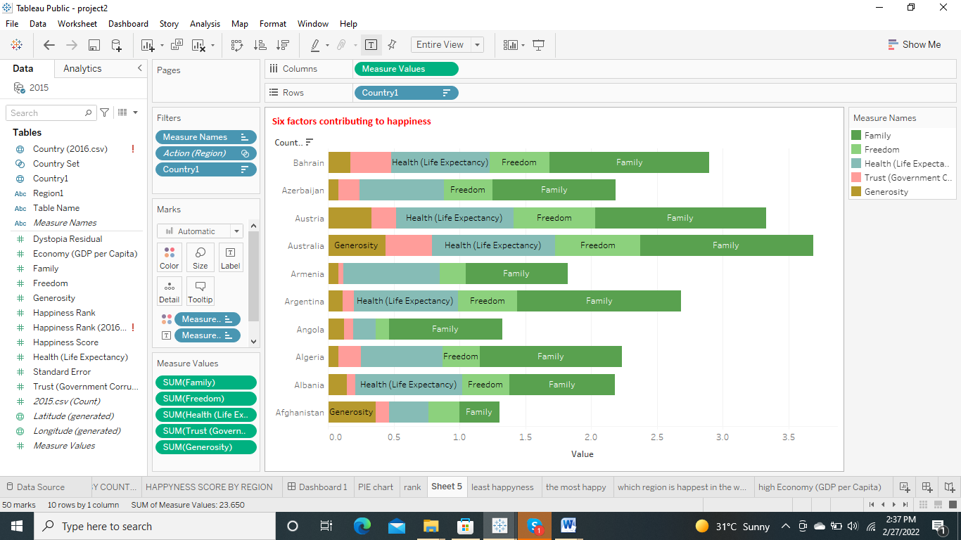

6.Which region country are having higher Happiness Score?

By country

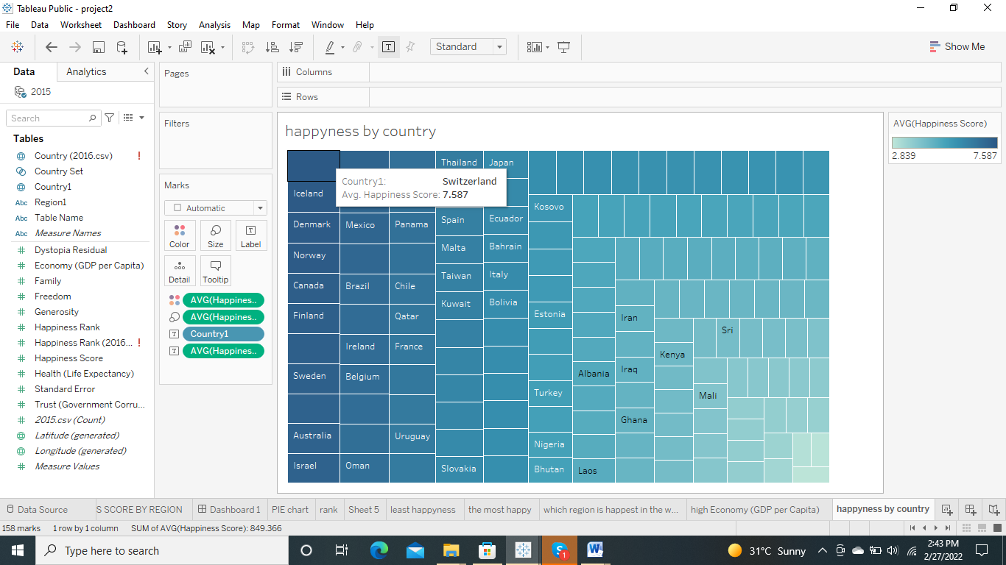

By regions

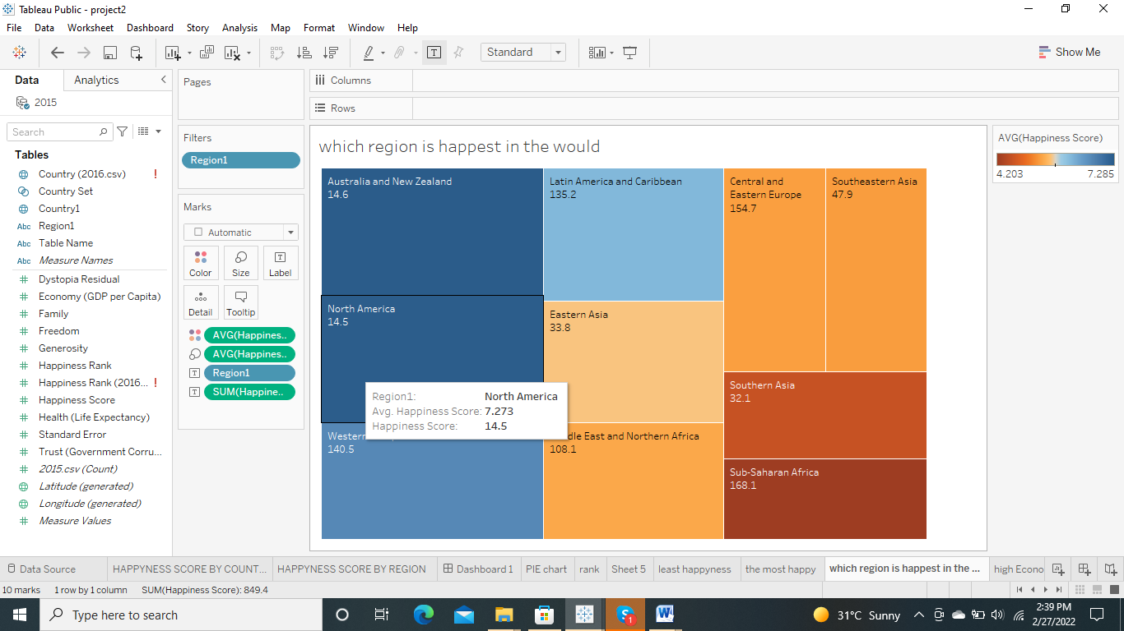

DASHBORD

